**PUNE VIDYARTHI GRIHA’s**

**COLLEGE OF ENGINEERING AND TECHNOLOGY**

**&**

**G K PATE (WANI) INSTITUTE OF MANAGEMENT, PUNE – 411 009**



**INTERNSHIP REPORT**

ON

**SELF BALANCING BIKE**

Under Supervision of

Mr. Kshitij Ghanekar {Embedded EV Engineer},

Belrise Industries

**(Date – 11/12/2023 to 31/01/2024)**

**SUBMITTED BY**

**Aniket Balasaheb Gund**

**(CRN Number 21112116)**

**(Seat Number T190073043)**

**Class TE (E&TC)**

**May 2024**

**DEPARTMENT OF E&TC ENGINEERING**

PVG’s COET & GKPIOM, PUNE-9

SAVITRIBAI PHULE PUNE UNIVERSITY

**I**

**DEPARTMENT OF E&TC ENGINEERING**

**PUNE VIDYARTHI GRIHA’s**

**COLLEGE OF ENGINEERING AND TECHNOLOGY**

**&**

**G K PATE (WANI) INSTITUTE OF MANAGEMENT, PUNE – 411 009**



**CERTIFICATE**

This is to certify that the “Internship report” submitted by **ANIKET BALASAHEB GUND & Exam Seat No.:T190073043 ,** is work done by his and submitted during 2023 - 2024 academic year, in partial fulfillment of the requirements for the Third Year Course in Electrical Engineering, Pune Vidyarthi Griha’s College Of Engineering & Technology And G K Pate (Wani) Institute of Management, Pune – 411 009

Prof. D. T. Varpe, Prof. N. D. Kuchekar Dr. K. J. Kulkarni

Department Internship Coordinator Head of the Department

Department of E&TC Engineering

**II**

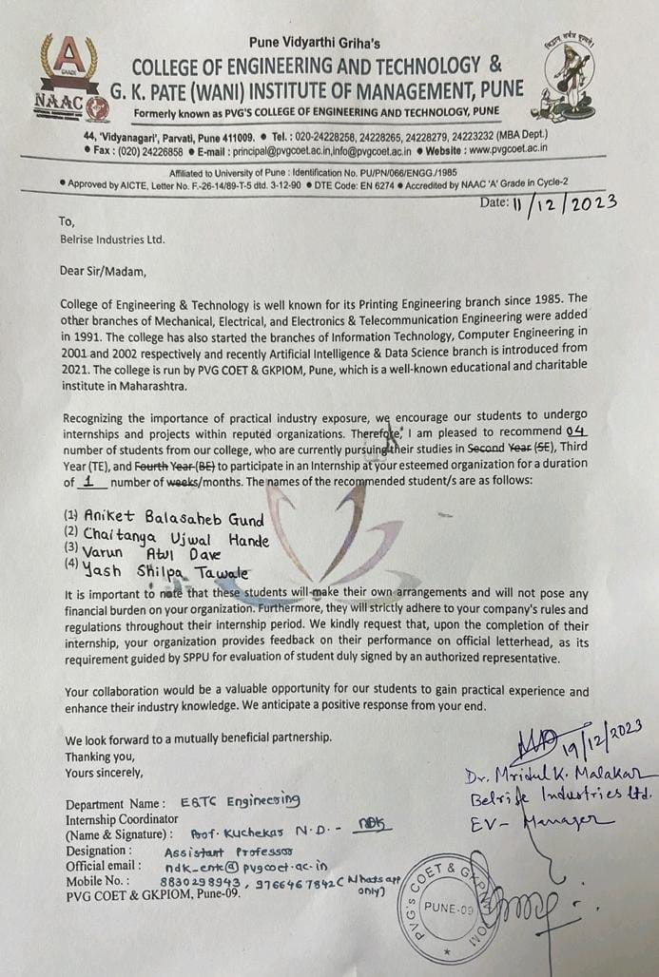

**III**

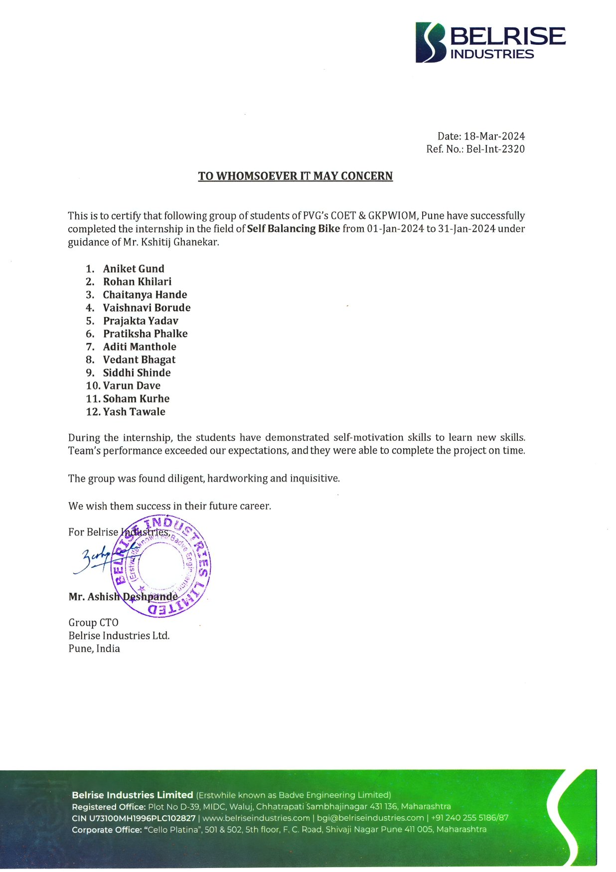

**IV**

**ACKNOWLEDGEMENT**

First I would like to thank Mr. Kshitij Ghanekar Embedded EV Engineer at Belrise Industries Ltd for giving me the opportunity to do an internship within the organization.

I also would like all the people that worked along with me {Belrise Industries} with their patience and openness they created an enjoyable working environment.

It is indeed with a great sense of pleasure and immense sense of gratitude that I acknowledge the help of these individuals.

I am highly indebted to Principal Dr. M. R. Tarambale, for the facilities provided to accomplish this internship.

I would like to thank my Head of the Department Dr. K. J. Kulkarni for his constructive criticism throughout my internship.

I would like to thank Prof. D. T. Varpe, Prof. N. D. Kuchekar, Department internship coordinator for his support and advice to get and complete internship in above said organization.

I am extremely grateful to my department staff members and friends who helped me in successful completion of this internship.

**V**

**ABSTRACT**

The self-balancing bike is a game-changer in urban transportation, blending electric power with cutting-edge stability tech. Its intuitive self-balancing system ensures riders of all skill levels can navigate confidently. By eliminating the need for balancing, it opens cycling to a wider audience, promoting inclusivity and accessibility. Not just eco-friendly, its electric design reduces carbon emissions, aligning with sustainable urban living.

Beyond its practical benefits, this innovation drives advancements in self-balancing technology, hinting at the future of electric vehicles. Moreover, it encourages active lifestyles by making cycling enjoyable for everyone. Future research aims at refining control algorithms, enhancing environmental awareness through sensor integration, and optimizing design for mass production. The self-balancing bike heralds safer, more accessible, and greener urban mobility.

The self-balancing bike embodies simplicity, accessibility, and sustainability, positioning itself at the forefront of urban innovation. Its transformative potential redefines how we navigate city streets, symbolizing a paradigm shift towards greener, more inclusive urban living. As we refine its technology and embrace its possibilities, the self-balancing bike becomes not just a mode of transportation, but a beacon of progress towards a brighter, more harmonious urban landscape.

The self-balancing bike promotes community bonding and social interaction, bringing people together as they enjoy active living and shared adventures. Its easy-to-use design encourages spontaneous exploration of city spaces, enhancing the vibrancy of urban life. As this technology progresses, its influence on city travel and social connections will be profound, reshaping our urban experiences for the better.

**VI**

**INDEX**

|  |  |  |
| --- | --- | --- |
| **SR N0** | **NAME OF THE TOPIC** | **Page No** |
| 1. | Introduction | 10 |
| 2. | Title | 11 |
| 3. | Aim | 11 |
| 4. | Objectives | 11 |
| 5. | Motivation | 12 |
| 6. | Scope | 12 |
| 7. | Methodology details | 13 |
| 8. | Block diagram | 14 |
| 9. | Working | 14 |
| 10. | Circuit Simulation | 15 |
| 11. | Component specification | 16 |
| 12. | Results | 19 |
| 13. | Analysis | 19 |
| 14. | Self-balancing bike prototype | 20 |
| 15. | Conclusion | 23 |
| 16. | Attendance record | 24 |
| 17. | Learning outcomes | 25 |
| 18. | References | 26 |

**VII**

**Worksheet of Internship**

**WEEK 1**

|  |  |  |  |
| --- | --- | --- | --- |
| **1st WE**  **E**  **K** | **DATE** | **DAY** | **NAME OF THE TOPIC/MODULE COMPLETED** |
| 12/12/23 | Monday | Introduction self-balancing bike |
| 13/12/23 | Tuesday | Topic finalization |
| 14/12/23 | Wednesday | Balancing algorithm introduction |
| 15/12/23 | Thursday | Research on balancing of bike |
| 16/12/23 | Friday | Literature survey |

**WEEK 2**

|  |  |  |  |
| --- | --- | --- | --- |
| **2ndWE**  **E**  **K** | **DATE** | **DAY** | **NAME OF THE TOPIC/MODULE COMPLETED** |
| 18/12/23 | Monday | Exploring related project ideas |
| 19/12/23 | Tuesday | Design calculations |
| 20/12/23 | Wednesday | I2C Protocol |
| 21/12/23 | Thursday | Research on sensors used |
| 22/12/23 | Friday | Research on control system |

**VIII**

**Worksheet of Internship**

**WEEK 3**

|  |  |  |  |
| --- | --- | --- | --- |
| **3rdWE**  **E**  **K** | **DATE** | **DAY** | **NAME OF THE TOPIC/MODULE COMPLETED** |
| 25/12/23 | Monday | Self-balancing bike components |
| 26/12/23 | Tuesday | Components specifications |
| 27/12/23 | Wednesday | Components testing |
| 28/12/23 | Thursday | Interfacing of gyro sensors |
| 29/12/23 | Friday | Interfacing and testing dc motors |

**WEEK 4**

|  |  |  |  |
| --- | --- | --- | --- |
| **4thWE**  **E**  **K** | **DATE** | **DAY** | **NAME OF THE TOPIC/MODULE COMPLETED** |
| 01/01/24 | Monday | Assembling of components |
| 02/01/24 | Tuesday | Circuit design for project |
| 03/01/24 | Wednesday | Implementation of prototype |
| 04/01/24 | Thursday | Final Testing of Bike |
| 05/01/24 | Friday | Documentation and conclusion |

**IX**

1. **Introduction**

Self-balancing bikes are a revolutionary invention that takes the challenge out of cycling, opening up the world of two-wheeled transportation to a wider range of people. Unlike traditional bicycles that require riders to master the delicate skill of balancing, self-balancing bikes use a combination of advanced sensors and clever algorithms to constantly monitor their tilt and make real-time adjustments to stay upright. This removes the fear of tipping over, a common hurdle for beginners and anyone hesitant about riding a traditional bike. With a self-balancing bike, riders can focus on the joy of the ride, whether they're navigating busy city streets, cruising along scenic paths, or simply enjoying a leisurely spin around the neighborhood.

This newfound confidence can lead to a surge in cycling popularity, making our streets safer and our communities healthier. Imagine a world where anyone, regardless of age or athletic ability, can hop on a bike and experience the freedom of cycling. Self-balancing bikes have the potential to make this a reality, paving the way for a more sustainable and enjoyable transportation future. But the benefits extend far beyond individual riders. Increased cycling can lead to reduced traffic congestion, cleaner air, and a more vibrant public realm. As more people discover the joy of cycling, cities can invest in safe and dedicated cycling infrastructure, creating a virtuous cycle that encourages even more people to ditch their cars and embrace a greener mode of transportation.

**X**

**2. Title:** Self-Balancing Bike

**3. Aim:** Contribute to the development of self-balancing technology for bicycles and explore its potential applications for improved accessibility and user engagement.

**4. Objectives:**

**Primary Objectives**:

• Build a functional, mini self-balancing bike prototype using a gyroscope for tilt detection and motor for balancing.

**Secondary Objectives**:

• Develop and implement a control algorithm that effectively translates sensor data into balancing actions. This involves tuning parameters and ensuring smooth, responsive operation.

• Integrate sensors (IMUs, accelerometers) to provide accurate real-time feedback on the bike's orientation and movement. This is crucial for the control algorithm to function effectively.

**Optional Additional Objectives:**

• Make the mini bike easy to control - add buttons to adjust balance or take manual control.

• Test the bike with people who have trouble balancing - see if it helps them ride.

• Find ways to improve the bike's design, controls, and how well it works.

**XI**

**5. Motivation:**

This self-balancing bike project is all about making cycling easier and safer for everyone. By taking away the need to learn how to balance, people of all ages and abilities will be able to hop on and enjoy the ride. This is especially helpful for people who have trouble balancing on a regular bike, or those who are new to cycling and might feel intimidated. With a self-balancing bike, they can still experience the fun, freedom, and health benefits of cycling without the fear of tipping over.

**6. Scope:**

The self-balancing bike's scope extends beyond transportation, integrating technology for urban mobility challenges. With advancements in machine learning, autonomy, and battery optimization, it redefines personal mobility with safety and accessibility. Evolving as part of smart city ecosystems, it promotes sustainable urban living and community engagement, shaping a greener, healthier urban future.

1. **Enhanced Safety Features:** Integrate collision detection systems and emergency braking mechanisms to further improve rider safety.
2. **Environmental Adaptability**: Develop adaptive suspension systems to adjust to different terrains and weather conditions, ensuring optimal performance in various environments.
3. **Personalization Options**: Provide customization features such as adjustable seat height, handlebar position, and riding modes to accommodate individual preferences and comfort levels.

**XII**

**7. Methodology Details:**

**1.Sensor Data Acquisition:**

**MPU 9250 Initialization:** Arduino Mega sends initialization signals to MPU 9250 via I2C.

**Continuous Data Reading:** MPU 9250 continuously measures gyroscope and accelerometer data.

**2. Data Transfer:**

**MPU 9250 Sends Data:** MPU 9250 retrieves data from specified registers and sends it back to Arduino Mega via I2C.

**Arduino Receives and Converts Data:** Arduino Mega reads received data and converts it into meaningful sensor values (degrees).

**3. Data Processing and Control:**

**Calculates Tilt and Orientation:** Arduino processes sensor data to determine bike's tilt angle and orientation in real-time.

**4.PWM Signal Generation:**

Arduino generates PWM (Pulse Width Modulation) signal and PWM signals control motor speed and direction.

**5. Balancing Mechanism:**

**Tilt Left:** Right motor rotates clockwise, the left motor rotates counter-clockwise.

This creates torque to counteract tilt and balance the bike.

**Tilt Right**: Motor directions are reversed, creating torque in the opposite direction to balance.

**Continuous Monitoring and Adjustment**: Process repeats continuously, monitoring sensor data, calculating adjustments, and sending control signals to maintain balance.

**XIII**

**8. BLOCK DIAGRAM**

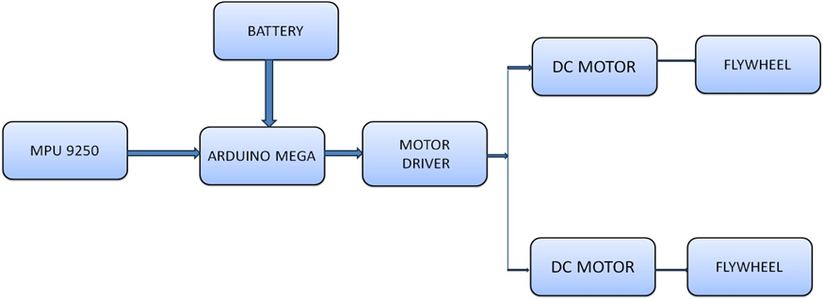

**9. Working:**

**Our self-balancing bike works like this:**

1. **Talkative Parts:** The brain (Arduino) talks to the tilt sensor (MPU 9250) to get constant updates on how the bike is leaning.
2. **Understanding the message**: The brain translates this information into easy-to-understand signals.
3. **Taking action:** Based on the lean, the brain tells the motor how fast and which way to spin to keep the bike upright.
4. **Repeat:** This keeps happening over and over, making sure the bike stays balanced for a smooth ride.

**XIV**

**10. Circuit Simulation:**

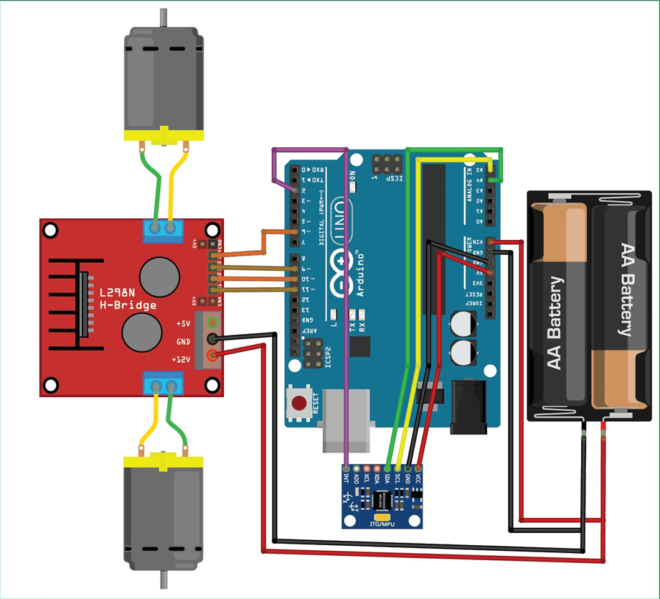

**XV**

**11. Component Specification:**

**1.Arduino Mega2560:**

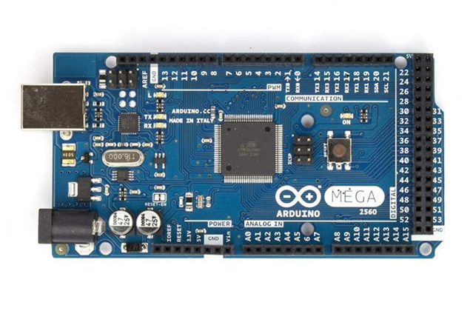

* Input Voltage: 7-12V
* Digital I/O Pins: 54
* Analog Input Pins: 16
* DC Current per I/O Pin: 40 mA

**2.MPU9250 Gyro sensor:**

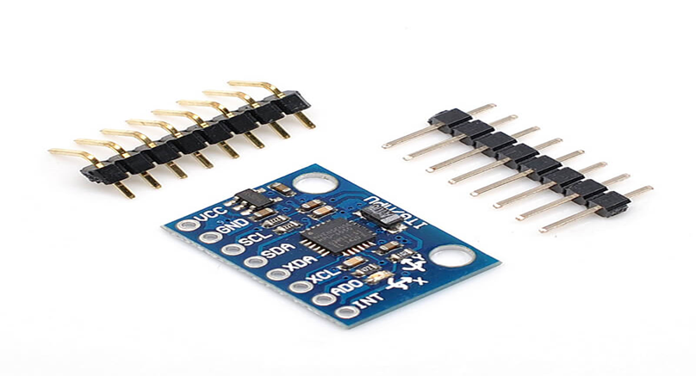

* 3-Axis Gyroscope
* 3-Axis Accelerometer Communication
* Interfaces: I2C and SPI
* Supply Voltage: 2.4V to 3.6V

**XVI**

**3. L298 H-Bridge Driver:**

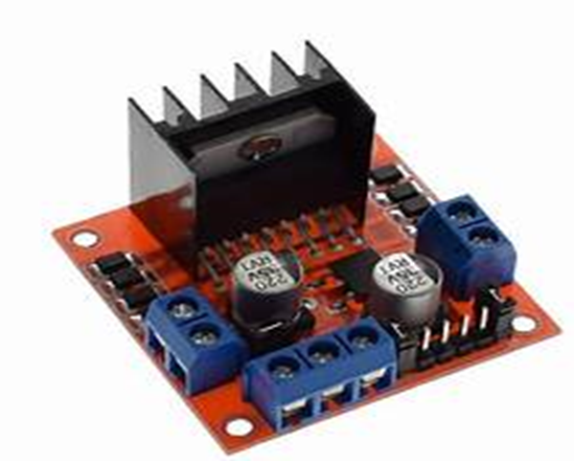

* Supply Voltage: 5V to 35V
* Output Current: 2A per bridge
* Output Voltage: Up to 46V

**4. LM298N Step down DC-DC Buck Converter:**

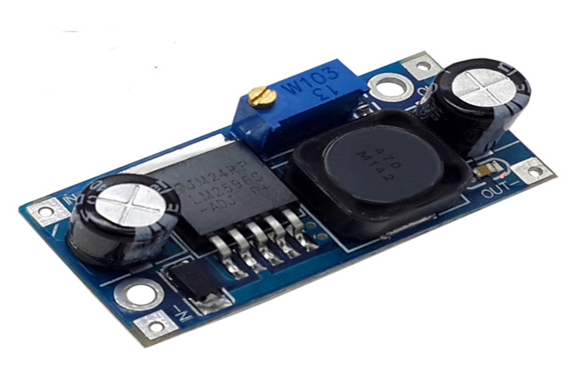

* Supply Voltage: 5V to 46V
* Output Current (Continuous): 2A
* Input Current: 25mA

**XVII**

**DC Motor:** Input voltage Range: 3.3 to 8 volts

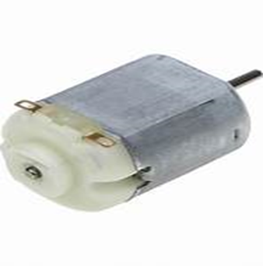

**Connecting Wires:**

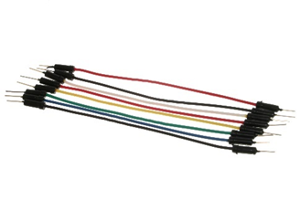

**Flywheels:**

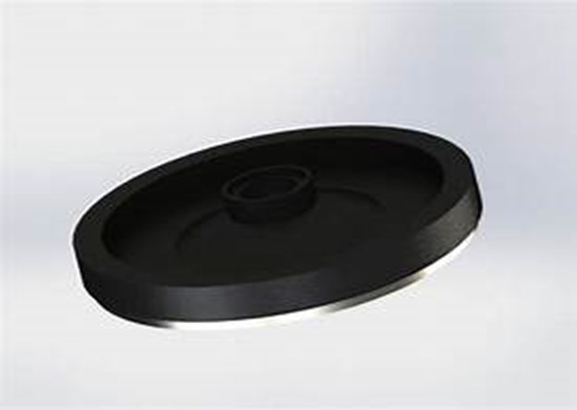

**XVIII**

**12. Results:**

Self-balancing electric bicycle or hoverbike, typically employs gyroscopic sensors and accelerometers to maintain balance while in motion. These sensors detect the bike's orientation and make real-time adjustments to keep it upright. Additionally, electronic control systems adjust the speed and direction of the bike to maintain stability.

self-balancing bikes offer a convenient and intuitive riding experience, making them popular for urban commuting and leisure activities.

**Personal Mobility:**

**• Recreational cycling:** Offering a more accessible and enjoyable experience for people with balance challenges, beginners, older adults, and those seeking a novel riding experience.

**• Urban commuting:** Providing a stable and potentially safer alternative to traditional bicycles for short-distance urban trips.

**• Last-mile delivery:** Enabling more efficient and eco-friendly delivery services in dense urban areas, potentially with cargo-carrying capabilities.

**13. Analysis:**

This thesis presents work on the use of a Control Moment Gyro (CMG) and a PD controller to balance a bicycle. The CMG was used as a momentum exchange actuator to balance the bicycle. The CMG is an effective torque amplification device and has a short response time.

A state space model of the bicycle with the CMG and a closed-loop controller was created in the control design assistant developed by National Instruments. Simulations were used to determine the performance of the controller and to find initial gains to be used in a real-time system for deployment. Simulation exercises showed that a PD controller is adequate for balancing the bicycle. A PID decreases the phase margin dramatically and the system becomes unstable and unable to balance the bicycle.

**XIX**

**14. SELF BALANCING BIKE PROTOTYPE:**

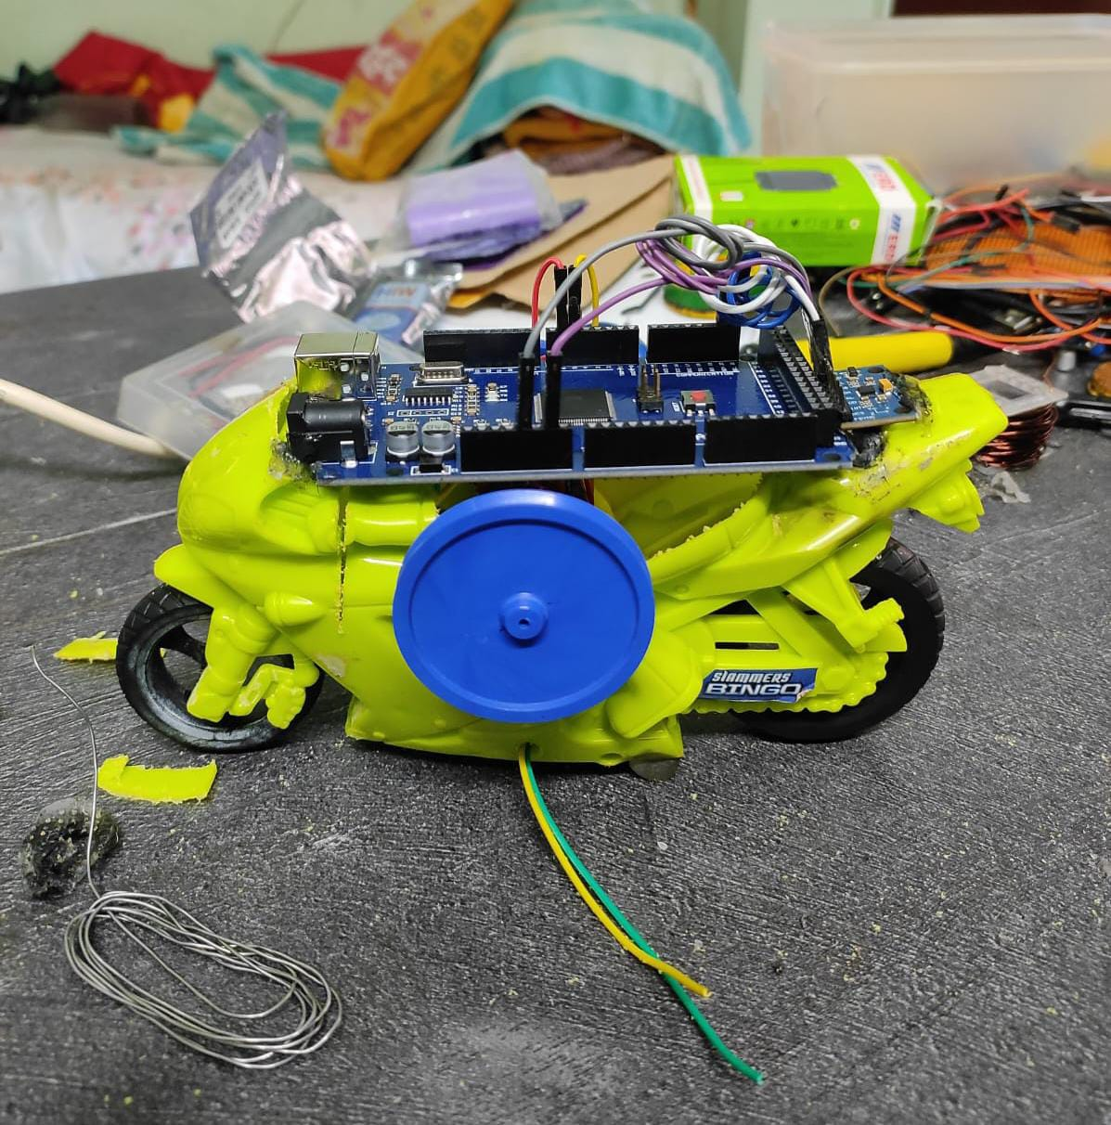

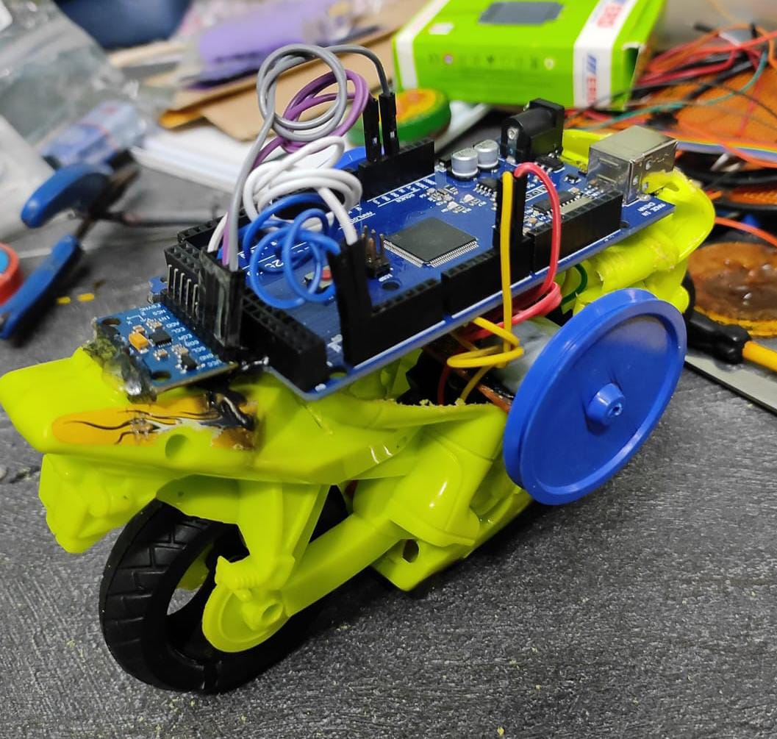

**XX**

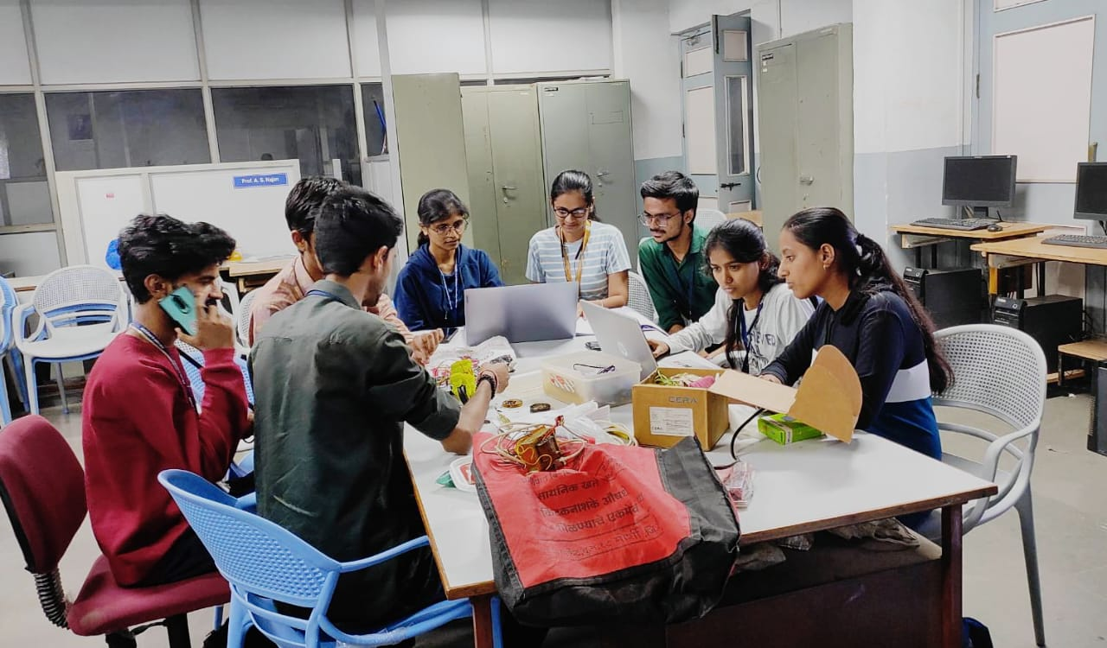

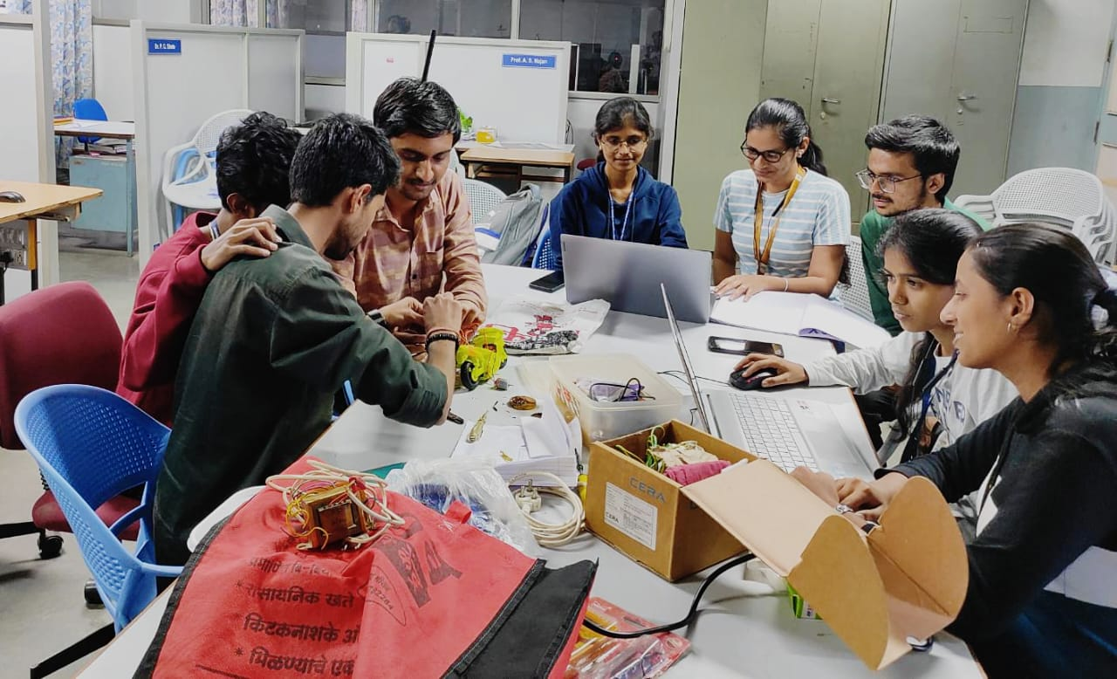

**XXI**

**Project Completion and Submission:**

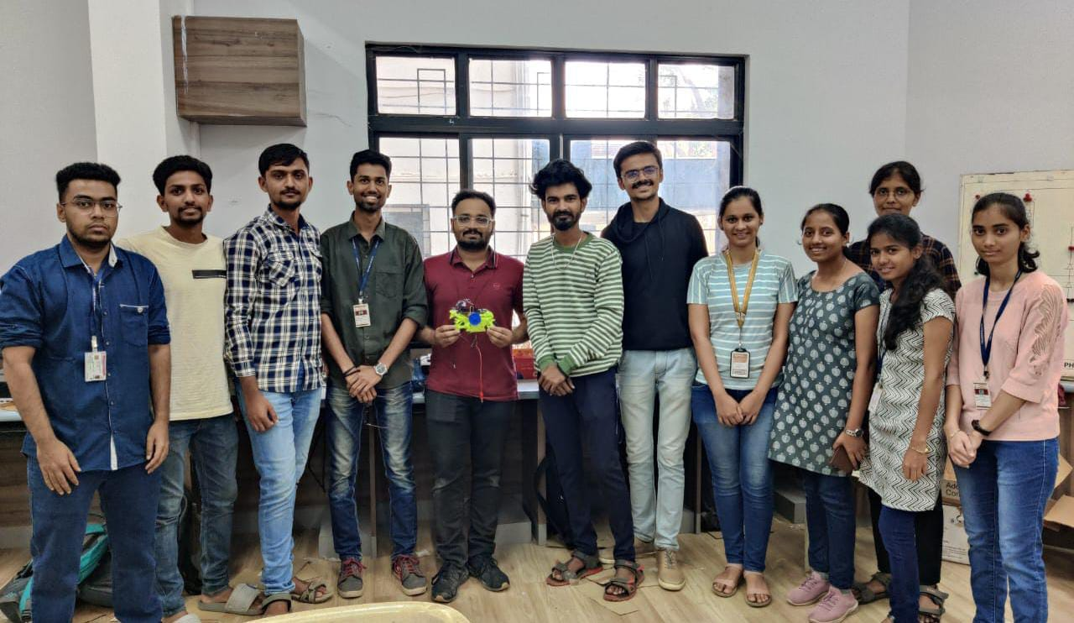

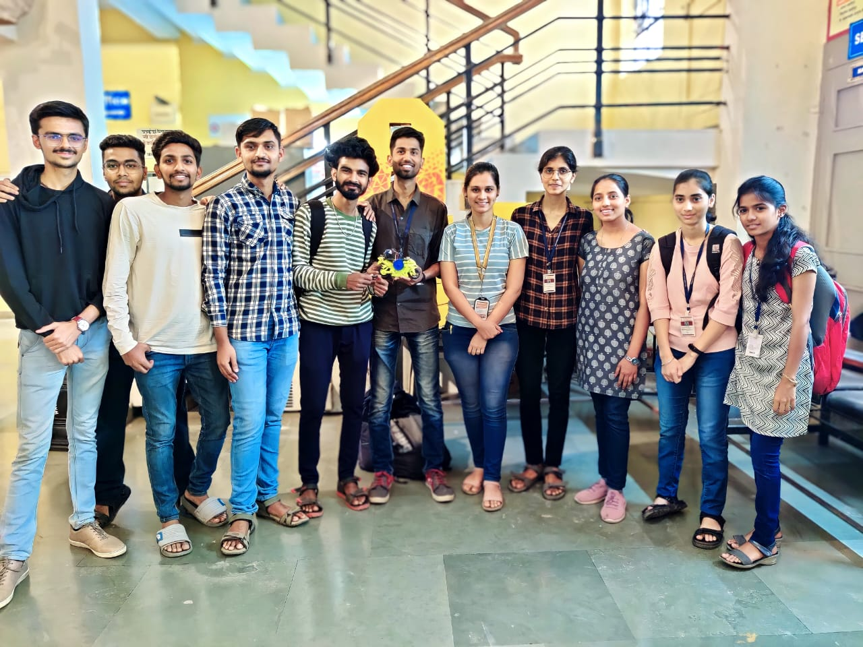

**XXII**

**15. Conclusion:**

This self-balancing bike is a whole new kind of bicycle! It uses fancy tech to stay upright, making it easier to ride than a regular bike. This is just the beginning - imagine bikes that take you anywhere in the city, with no sweat or hassle. They could even help people with balance problems get around safely. And in the future, who knows? Maybe we'll have self-driving bikes that take us wherever we want to go, or super cool bikes that adjust to how we like to ride! The future of bikes is looking awesome and full of possibilities.

**XXIII**

**16. Attendance Record:**

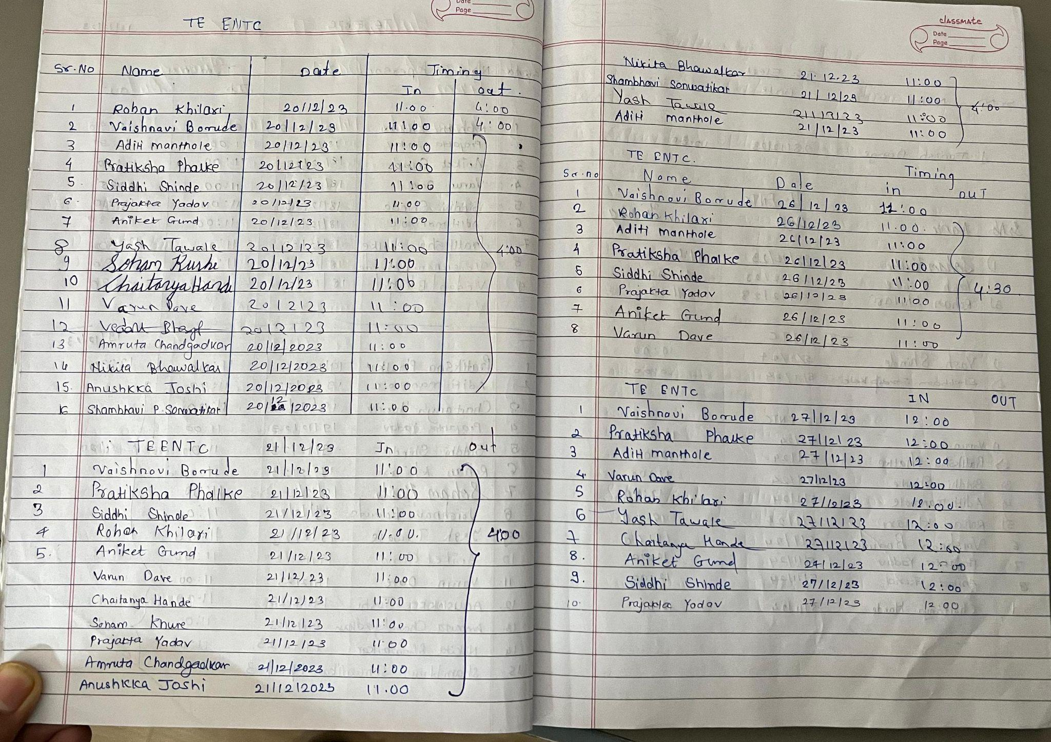

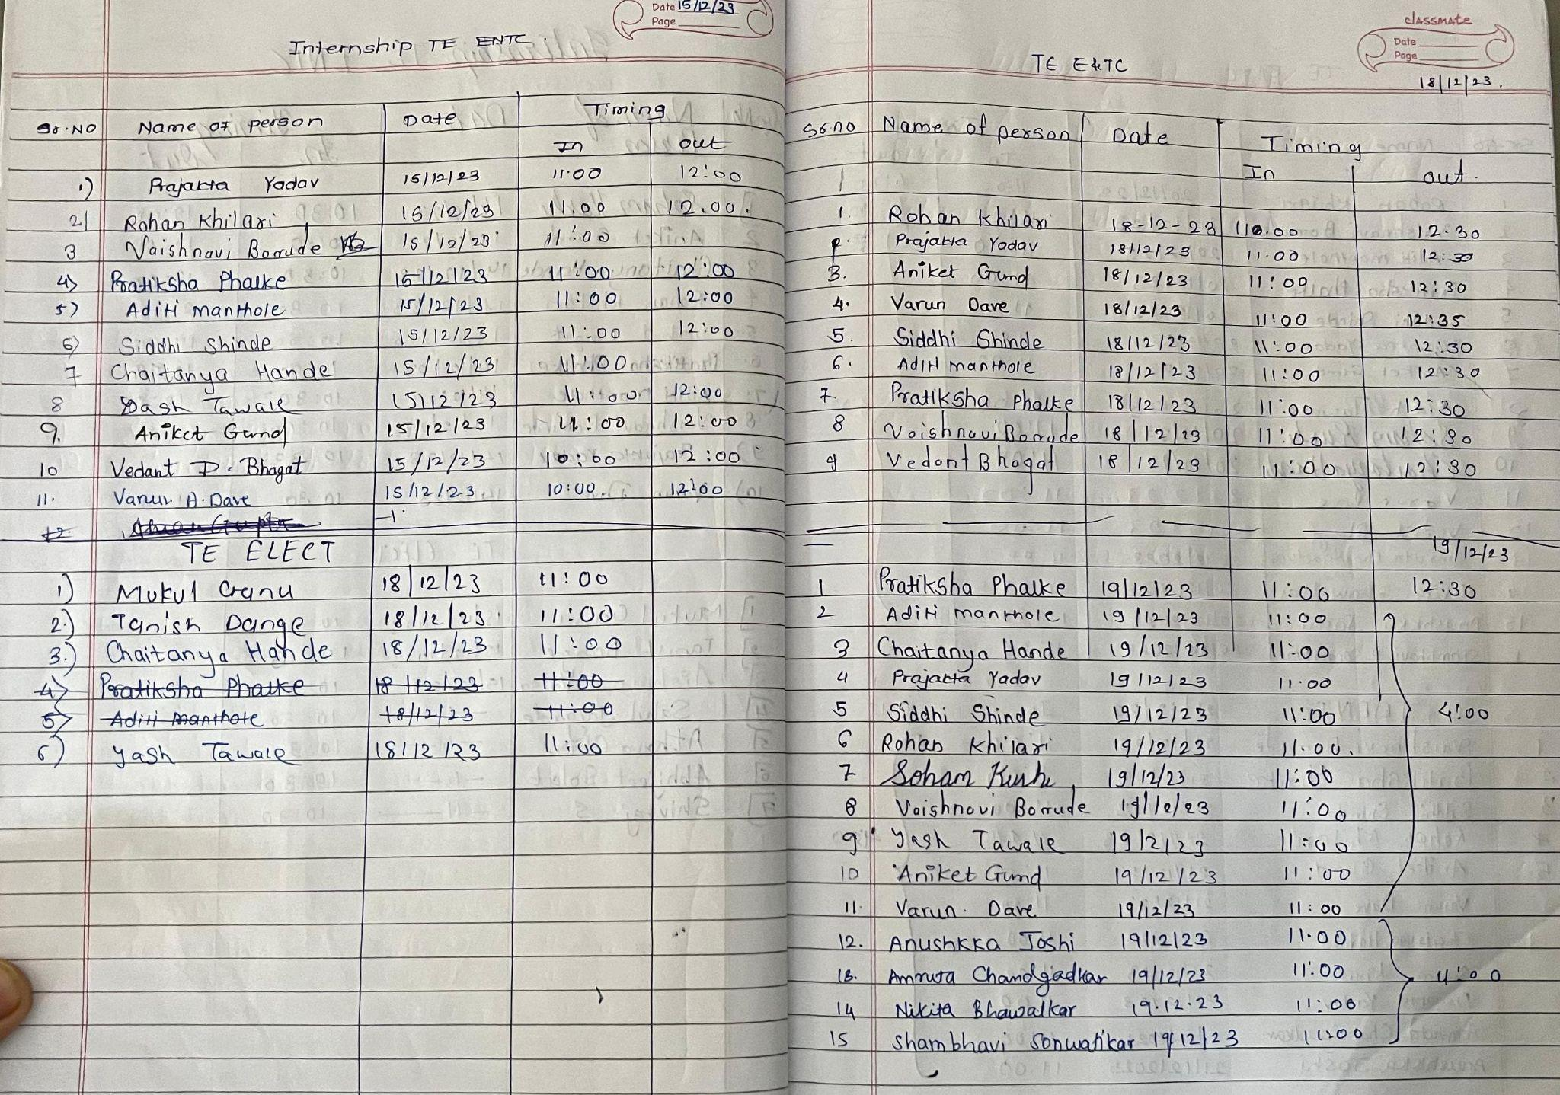

**XXIV**

**17. Learning Outcomes**

* **Learned & grew**: Gained skills in embedded systems programming & troubleshooting on self-balancing vehicle project. Improved communication & teamwork. Overcame complex designing challenges.
* **Positive impact:** Praised for problem-solving skills & contributions to brainstorming sessions. Improved code documentation based on supervisor feedback.
* **Confidence & clarity:** Internship boosted confidence & motivation for embedded systems engineering career. Increased self-awareness of troubleshooting & critical thinking strengths.
* **Relevance & takeaways:** Applied classroom knowledge to project. Learned about design iteration & testing in hardware development. Recommend internship for understanding practical applications in electronics & telecom.

**XXV**

**18. References**

**·** [**https://in.mathworks.com/help/supportpkg/arduino/ref/gyroscope-based- pedometer.html**](https://in.mathworks.com/help/supportpkg/arduino/ref/gyroscope-based-%20%20%20%20%20%20%20%20pedometer.html)

**·**[**https://in.mathworks.com/help/supportpkg/arduino/ref/read-temperature-from-an-i2c-based-sensor-using-arduino-hardware.html**](https://in.mathworks.com/help/supportpkg/arduino/ref/read-temperature-from-an-i2c-based-sensor-using-arduino-hardware.html)

**·** [**https://www.mathworks.com/help/supportpkg/arduino/ug/support-i2c-communication.html**](https://www.mathworks.com/help/supportpkg/arduino/ug/support-i2c-communication.html)

**·** [**https://robu.in/product/l298-based-motor-driver-module-2a/**](https://robu.in/product/l298-based-motor-driver-module-2a/)

**·** [**https://in.mathworks.com/help/supportpkg/arduino/ref/estimate-orientation-ahrs.html**](https://in.mathworks.com/help/supportpkg/arduino/ref/estimate-orientation-ahrs.html)

**·** [**https://circuitdigest.com/microcontroller-projects/arduino-based-self-balancing-robot**](https://circuitdigest.com/microcontroller-projects/arduino-based-self-balancing-robot)

**·** [**https://in.mathworks.com/support/search.html/videos/sensor-fusion-part-2-fusing-a-mag-accel-and-gyro-to-estimate-orientation-1569411056638.html?fq%5B%5D=asset_type_name:video&fq%5B%5D=category:fusion/index&page=1**](https://in.mathworks.com/support/search.html/videos/sensor-fusion-part-2-fusing-a-mag-accel-and-gyro-to-estimate-orientation-1569411056638.html?fq%5B%5D=asset_type_name:video&fq%5B%5D=category:fusion/index&page=1)

**·**[**https://youtu.be/mzwovYcozvI?si=CifB9taw1Je8qim6**](https://youtu.be/mzwovYcozvI?si=CifB9taw1Je8qim6)

**·**  [**https://youtu.be/h_t1NAlpcsE?si=LuGjwYLJrCgo3epV**](https://youtu.be/h_t1NAlpcsE?si=LuGjwYLJrCgo3epV)

**·** [**https://forum.arduino.cc/t/using-mpu9250-imu-with-arduino-mega-for-getting-euler-angles/914736**](https://forum.arduino.cc/t/using-mpu9250-imu-with-arduino-mega-for-getting-euler-angles/914736)

**·** [**https://youtu.be/OF49fnNMHhw?si=-PHSjEUJzkyPSYzn**](https://youtu.be/OF49fnNMHhw?si=-PHSjEUJzkyPSYzn)

**XXVI**